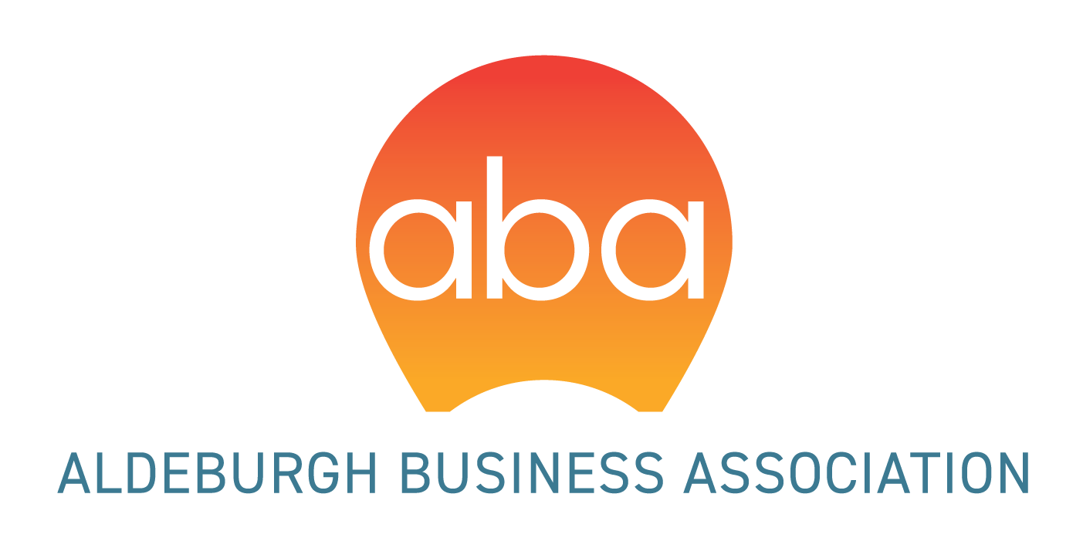

ABA MEMBERSHIP FORM

Benefits of belonging to ABA
- A forum to access and share information on the town and surrounding area
- Access to 6 business breakfasts
- Ideal networking opportunities
- Advance knowledge of local events
- Sharing of best practice with like-minded business owners/managers
- Opportunities to market your business locally

The more members we have the louder our voice on local issues.

Want to join? Please fill in the following information:

Your business name:

Business Address:

Contact name:

Email (to receive ABA newsletter and meeting invitations
Telephone (landline or mobile):

Payment: BACS or cheque/cash at £52 per annum

ABA bank details: Barclays Bank, sort code:20-98-07, account number 00341398

Please deliver or post this form clearly marked for the attention of the ABA (and a cheque made out to Aldeburgh Business Association if needed) to: Ipswich Building Society, 103 High Street, Aldeburgh IP15 5AR.

We will happily share details of events and offers via our Facebook page and website, if you don’t want us to do this please tick the box. 🔲

For any queries or questions please email the committee: info@aldeburghsuffolk.com

